**Set Wifi**

* **SSID：** GRBL_ESP
* **password：** 12345678
* **IP**：192.168.0.1

**Connect Grbl_ESP32 to Internet**

**WebUi**

Connect to Grbl_ESP32,loading WebUI.Click ESP32 and complete below:

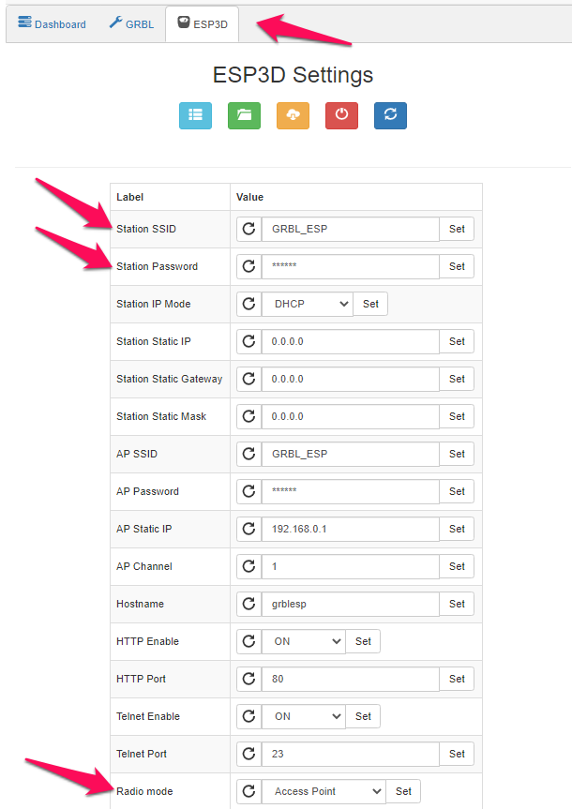

**Serial Terminal**

* $Sta/SSID=Your SSID
* $Sta/PASSWORD=Your password

$Radio/mode=STA

**Compile network settings**

Enable parameters in config.h as below

//Connect to your local AP with these credentials

//#define CONNECT_TO_SSID "your SSID"

//#define SSID_PASSWORD "your SSID password"

Send $Radio/Mode=STA before compile,then reboot after enable.

**Confirm current setting**

The following is method to confirm current setting through USB/serial port. No password will be notified. If lost password, send $RST=$ to reset or reload firmware.

* **$I** Basic connection information
* **$System/Stats** Wifi or system info
* **$WiFi/ListAPs** WiFi access point and signal strength

Note: Default authentication in the firmware is disable. When enable, second level of authentication is required to access the machine. The default user is "admin" and password is "admin".

*#define ENABLE_AUTHENTICATION*

**Using on smartphone**

If you try to connect your phone to Grbl_ESP32, may fail to access the Internet.

The best solution is to connect ESP32 to your home WiFi and using your phone. This will allow the phone to connect ESP32 and internet.